1.Write the following application. The initial page is called Validator.aspx and it has 7 text boxes representing (Name, Family Name, Address, City, Zip Code, Phone and e-mail address) and a Check button.

User gets the following page after clicking on Check button:

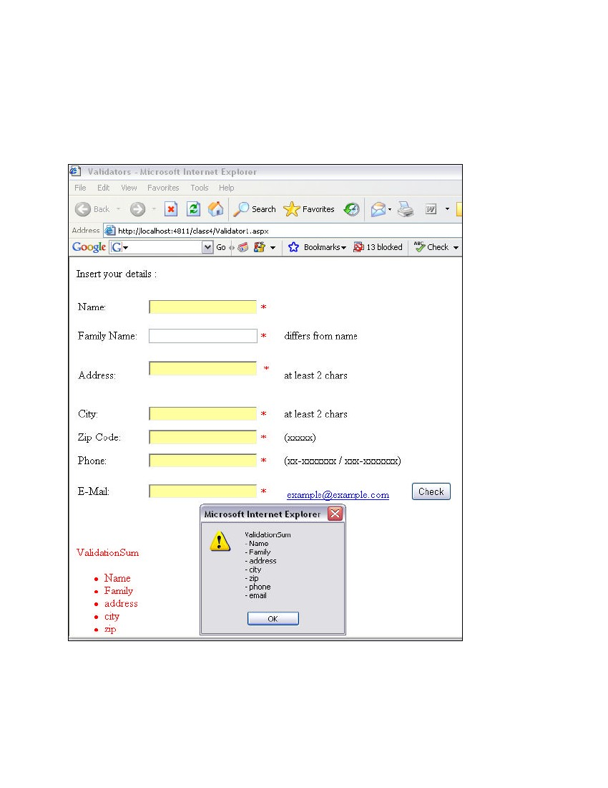

2. Create a web application that hosts a series of products (any) as a dropdown list.

Have a image control that can display the image of the selected item in the dropdown

have a button control that gets the price of the selected product and displays it in a Label control

The required validation actions are:

* name different from family name,
* address at least 2 letters,
* city at least 2 letters,
* zip-code 5 digits,
* phone according to the format XX-XXXXXXX or XXX-XXXXXXX,

e-mail is a valid email.